P.O. Box 7028 Riverview, New Brunswick, Canada, E1B 4T8

October 2023

Re: Criminal Record Check/ Vulnerable Sector Check

To Whom It May Concern:

Hockey New Brunswick requires that all volunteers 18 years of age and older with amateur hockey, in any capacity or title, complete a Vulnerable Sector Check and Criminal Record Check before they are permitted to volunteer.

This is to confirm that insert name here is a volunteer with Riverview Minor Hockey Club.

The club is aware that volunteers in possession of this letter will be submitting paperwork for RCMP background checks.

Yours truly,

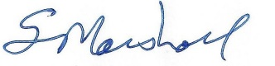

Stephen Marshall
Executive Director
Riverview Minor Hockey Club

